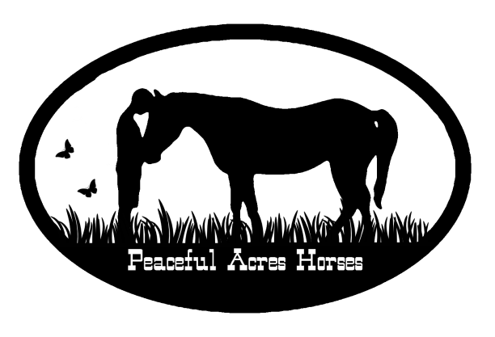
Rest Rejuvenate Restore
Peaceful Acres Horses’ facilitators and horses will be honored to lead you through a day of peace and pampering ~ July 18, 2015 from 9:30 – 4:30 or August 22nd 9:30 – 4:30
Offering a day of : Meditation, gentle yoga ( yoga nidra), time in nature, equine guided experiential learning, massage and a nutritious lunch.
Where: Peaceful Acres Horses
www.peacefulacreshorses.com for more details
Tuition: $ 65
please mail your tuition check, payable to Peaceful Acres Horses, along with this form to 3740 Rynex Corners Rd. Pattersonville, NY 12137
Please circle one: I plan to attend July 18, 2015 I plan to attend August 22, 2015
Please dress to be outdoors and wear comfortable clothing
Name: __________________________________________________________ Cell: ________________________
Address:_____________________________________________________________________________________________
Email: _______________________________________________________________________________________________
Acceptance of Responsibility & Release of Liability Program: Rejuvenation Workshop
I, the undersigned, hereby acknowledge that I have registered to participate in an activity which includes interaction with horses. Equine Guided Experiential Learning, as conducted at Peaceful Acres Horses, Inc., is a non-riding based program where horses are partnered in activities with youth and adults in ground work exercises where the participant learns vital life skills, including behavioral controls and capacity building.
I understand that any activity associated with horses involves numerous inherent risks of injury. I and or my family further understand that an animal, irrespective of its training and usual past behavior and characteristics may act or react unexpectedly or unpredictably. As consideration for being permitted by Peaceful Acres Horses, Inc. to engage in the activity of equine guided experiential learning & ground work exercises, I do hereby release Peaceful Acres Horses, Inc., and The HighPoint at Peaceful Acres, LLC and all other owners, officers, members, family, affiliated organizations, land owners or employees for injury or death caused by or resulting from my participation in the activity of equine guided experiential learning or ground work exercises.
I have carefully read this agreement and fully understand its contents. I am aware that I am releasing certain legal rights that otherwise I may have, and I enter into the contract on behalf of myself of my own free will.
THIS IS A RELEASE OF LIABILITY. DO NOT SIGN OR INITIAL THIS RELEASE IF YOU DO NOT UNDERSTAND OR DO NOT AGREE WITH ITS TERMS.
Signature:____________________________________________________________ Date: ________________________
Emergency Contact:______________________________________________Cell:____________________________

